MOVIE RECOMMENDER SYSTEM
A
Mini Project Report

Submitted in partial fulfilment of the
Requirements for the award of the Degree of
BACHELOR OF ENGINEERING
IN
COMPUTER SCIENCE & ENGINEERING
By
M. Tejasri-1602-20-748-054
M. Vaishnavi-1602-20-748-056

Department of Computer Science & Engineering
Vasavi College of Engineering (Autonomous)
(Affiliated to Osmania University)
Ibrahimbagh, Hyderabad-31
2021-22

Vasavi College of Engineering (Autonomous)
(Affiliated to Osmania University)
Hyderabad-500 031
Department of Computer Science & Engineering
DECLARATION BY THE CANDIDATE
We, M. Tejasri and M. Vaishnavi, bearing hall ticket number, 1602-20-748-054&056, hereby declare that the project report entitled Movie Recommendation System Department of Computer Science & Engineering, VCE, Hyderabad, is submitted in partial fulfilment of the requirement for the award of the degree of Bachelor of Engineering in Computer Science & Engineering.
This is a record of bonafide work carried out by me and the results embodied in this project report have not been submitted to any other university or institute for the award of any other degree or diploma.
M. Tejasri-1602-20-748-054
M. Vaishnavi-1602-20-748-056
Vasavi College of Engineering (Autonomous)
(Affiliated to Osmania University)
Hyderabad-500 031
Department of Computer Science & Engineering
BONAFIDE CERTIFICATE
This is to certify that the project entitled Movie Recommendation System being submitted by M. Tejasri and M. Vaishnavi, bearing 1602-20-748-054&056, in partial fulfilment of the requirements for the award of the degree of Bachelor of Engineering in Computer Science & Engineering is a record of bonafide work carried out by him/her under my guidance.

Dr. T. Adilakshmi,
Professor & HOD,
Dept. of CSE,

ACKNOWLEDGEMENT
The satisfaction and euphoria that accompanies the successful completion of any task would be incomplete without the mention of the people made it possible and whose encouragement and guidance have made our efforts with success.
We are indebted to the Internal Guide, B. Syamala, ASSISTANT PROFESSOR, Computer Science & Engineering, VASAVI COLLEGE OF ENGINEERING, Ibrahimbagh, hyd-31 for her support and guidance throughout the project.
We are also indebted to the Head of the Department, Dr. T. Adilakshmi, PROFESSOR, Computer Science and Engineering, VASAVI COLLEGE OF ENGINEERING, Ibrahimbagh, hyd-31 for her support and guidance throughout the project.
We extend our deep sense of gratitude to the Principal, S. V. RAMANA RAO, VASAVI COLLEGE OF ENGINEERING, Ibrahimbagh, hyd-31 permitting us to undertake this project.
ABSTRACT
In this hustling world, entertainment is a necessity for each one of us to refresh our mood and energy. Entertainment regains our confidence for work and we can work more enthusiastically. For revitalizing ourselves, we can listen to our preferred music or can watch movies of our choice. For watching favourable movies online we can utilize movie recommendation systems, which are more reliable, since searching of preferred movies will require more and more time which one cannot afford to waste. In this paper, to improve the quality of a movie recommendation system, a Hybrid approach by combining content based filtering and collaborative filtering, using Support Vector Machine as a classifier and genetic algorithm is presented in the proposed methodology and comparative results have been shown which depicts that the proposed approach shows an improvement in the accuracy, quality and scalability of the movie recommendation system than the pure approaches in three different datasets. Hybrid approach helps to get the advantages from both the approaches as well as tries to eliminate the drawbacks of both methods.
Recommendation systems are computer programs that suggest recommendations to users depending on a variety of criteria. This movie recommendation system can suggest a set of movies to users based on their interest or the popularity of the movie. It first captures the similarity of movies and then recommends the movie .The similarity is calculated based on the information of items that are choose by the user and then make the recommendation accordingly.

TABLE OF CONTENTS
S.No. | Contents | Page no.
1 | Abstract | 6
2 | Introduction | 7
3 | Objectives | 8
4 | Methodology | 9
5 | Hardware and software requirements | 10
6 | Libraries and Packages | 11
7 | Source code | 12-18
8 | Output | 19
9 | Conclusion | 20
10 | References | 21

INTRODUCTION
A recommendation system or recommendation engine is a model used for information filtering where it tries to predict the preferences of a user and provide suggests based on these preferences. These systems have become increasingly popular nowadays and are widely used today in areas such as movies, music, books, videos, clothing, restaurants, food, places and other utilities. These systems collect information about a user's preferences and behaviour, and then use this information to improve their suggestions in the future. Movies are a part and parcel of life. There are different types of movies like some for entertainment, some for educational purposes, some are animated movies for children, and some are horror movies or action films. Movies can be easily differentiated through their genres like comedy, thriller, animation, action etc. Other way to distinguish among movies can be either by releasing year, language, director etc. Watching movies online, there are a number of movies to search in our most liked movies . Movie Recommendation Systems helps us to search our preferred movies among all of these different types of movies and hence reduce the trouble of spending a lot of time searching our favourable movies. So, it requires that the movie recommendation system should be very reliable and should provide us with the recommendation of movies which are exactly same or most matched with our preferences. A large number of companies are making use of recommendation systems to increase user interaction and enrich a user's shopping experience. Recommendation systems have several benefits, the most important being customer satisfaction and revenue. Movie Recommendation system is very powerful and important system. But, due to the problems associated with pure collaborative approach, movie recommendation systems also suffers with poor recommendation quality and scalability issues.

Problem Statement:
The goal of the project is to recommend a movie to the user. Providing related content out of relevant collection of items to users of online service providers.
Objective of the Projects
• Improving the Accuracy of the recommendation system
• Improve the Quality of the movie Recommendation system
• Improving the Scalability.
• Enhancing the user experience.

Scope of the Project
The objective of this project is to provide accurate movie recommendations to users. The goal of the project is to improve the quality of movie recommendation system, such as accuracy, quality and scalability of system than the pure approaches. This is done using Hybrid approach by combining content based filtering and collaborative filtering, To eradicate the overload of the data, recommendation system is used as information filtering tool in social networking sites. Hence,there is a huge scope of exploration in this field for improving scalability, accuracy and quality of movie recommendation systems Movie Recommendation system is very powerful and important system. But, due to the problems associated with pure collaborative approach, movie recommendation systems also suffers with poor recommendation quality and scalability issues.
METHODOLOGY
1.collecting the data sets: Collecting all the required data set from tmdb 5000 movies this project we require movie.csv,ratings.csv,users.csv.
2.Data Analysis: make sure that that the collected data sets are correct and analysing the data in the csv files. i.e. checking whether all the column Felds are present in the data sets.
3.Algorithms: in our project we have only two algorithms one is cosine similarity and vectorization are used to build the machine learning recommendation model.

HARDWARE REQUIREMENTS
• A PC with Windows/Linux OS
• Processor with 1.7-2.4gHz speed
• Minimum of 8gb RAM
• 2gb Graphic card

SOFTWARE REQUIREMENTS
• Jupyter
• PyCharm Editor
• Python libraries

LIBRARIES USED
• NumPy
• Pandas
• Streamlit
• Requests
• pickle
• scikit learn
SOURCE CODE

JUPYTER NOTEBOOK:

import numpy as np # linear algebra
import pandas as pd # data processing, CSV file I/O (e.g. pd.read_csv)

import os
for dirname, _, filenames in os.walk('/kaggle/input'):
for filename in filenames:
print(os.path.join(dirname, filename))

movies = pd.read_csv('/kaggle/input/tmdb-movie-metadata/tmdb_5000_movies.csv')
credits = pd.read_csv('/kaggle/input/tmdb-movie-metadata/tmdb_5000_credits.csv')

movies.head(2)

movies.shape

(4803, 20)

credits.head()
movies = movies.merge(credits,on='title')

movies.head()
# budget
# homepage
# id
# original_language
# original_title
# popularity
# production_comapny
# production_countries
# release-date(not sure)

movies = movies[['movie_id','title','overview','genres','keywords','cast','crew']]

movies.head()
import ast

def convert(text):
L = []
for i in ast.literal_eval(text):
L.append(i['name'])
return L

movies.dropna(inplace=True)

movies['genres'] = movies['genres'].apply(convert)
movies.head()
movies['keywords'] = movies['keywords'].apply(convert)
movies.head()

import ast
ast.literal_eval('[{"id": 28, "name": "Action"}, {"id": 12, "name": "Adventure"}, {"id": 14, "name": "Fantasy"}, {"id": 878, "name": "Science Fiction"}]')

def convert3(text):
L = []
counter = 0
for i in ast.literal_eval(text):
if counter < 3:
L.append(i['name'])
counter+=1
return L

movies['cast'] = movies['cast'].apply(convert)
movies.head()
movies['cast'] = movies['cast'].apply(lambda x:x[0:3])

def fetch_director(text):
L = []
for i in ast.literal_eval(text):
if i['job'] == 'Director':
L.append(i['name'])
return L

movies['crew'] = movies['crew'].apply(fetch_director)

#movies['overview'] = movies['overview'].apply(lambda x:x.split())
movies.sample(5)
def collapse(L):
L1 = []
for i in L:
L1.append(i.replace(" ",""))
return L1

movies['cast'] = movies['cast'].apply(collapse)
movies['crew'] = movies['crew'].apply(collapse)
movies['genres'] = movies['genres'].apply(collapse)
movies['keywords'] = movies['keywords'].apply(collapse)

movies.head()
movies['overview'] = movies['overview'].apply(lambda x:x.split())

movies['tags'] = movies['overview'] + movies['genres'] + movies['keywords'] + movies['cast'] + movies['crew']

new = movies.drop(columns=['overview','genres','keywords','cast','crew'])
#new.head()

new['tags'] = new['tags'].apply(lambda x: " ".join(x))
new.head()
from sklearn.feature_extraction.text import CountVectorizer
cv = CountVectorizer(max_features=5000,stop_words='english')

vector = cv.fit_transform(new['tags']).toarray()

vector.shape

from sklearn.metrics.pairwise import cosine_similarity

similarity = cosine_similarity(vector)

similarity

new[new['title'] == 'The Lego Movie'].index[0]

def recommend(movie):
index = new[new['title'] == movie].index[0]
distances = sorted(list(enumerate(similarity[index])),reverse=True,key = lambda x: x[1])
for i in distances[1:6]:
print(new.iloc[i[0]].title)

recommend('Gandhi')

import pickle

pickle.dump(new,open('movie_list.pkl','wb'))
pickle.dump(similarity,open('similarity.pkl','wb'))

PYCHAM:
import streamlit as st
import requests
import pickle
def fetch_poster(movie_id):
url = "https://api.themoviedb.org/3/movie/{}?api_key=8265bd1679663a7ea12ac168da84d2e8&language=en-US".format(movie_id)
data = requests.get(url)
data = data.json()
poster_path = data['poster_path']
full_path = "https://image.tmdb.org/t/p/w500/" + poster_path
return full_path
def recommend(movie):
index = movies[movies['title'] == movie].index[0]
distances = sorted(list(enumerate(similarity[index])), reverse=True, key=lambda x: x[1])
recommended_movie_names = []
recommended_movie_posters = []
for i in distances[1:6]:
# fetch the movie poster
movie_id = movies.iloc[i[0]].movie_id
recommended_movie_posters.append(fetch_poster(movie_id))
recommended_movie_names.append(movies.iloc[i[0]].title)
return recommended_movie_names,recommended_movie_posters
st.header('Movie Recommender System')
movies = pickle.load(open('model/movie_list.pkl','rb'))
similarity = pickle.load(open('model/similarity.pkl','rb'))
movie_list = movies['title'].values
selected_movie = st.selectbox(
"Type or select a movie from the dropdown",
movie_list
)
if st.button('Show Recommendation'):
recommended_movie_names,recommended_movie_posters = recommend(selected_movie)
col1, col2, col3, col4, col5 = st.beta_columns(5)
with col1:
st.text(recommended_movie_names[0])
st.image(recommended_movie_posters[0])
with col2:
st.text(recommended_movie_names[1])
st.image(recommended_movie_posters[1])
with col3:
st.text(recommended_movie_names[2])
st.image(recommended_movie_posters[2])
with col4:
st.text(recommended_movie_names[3])
st.image(recommended_movie_posters[3])
with col5:
st.text(recommended_movie_names[4])
st.image(recommended_movie_posters[4])

OUTPUT
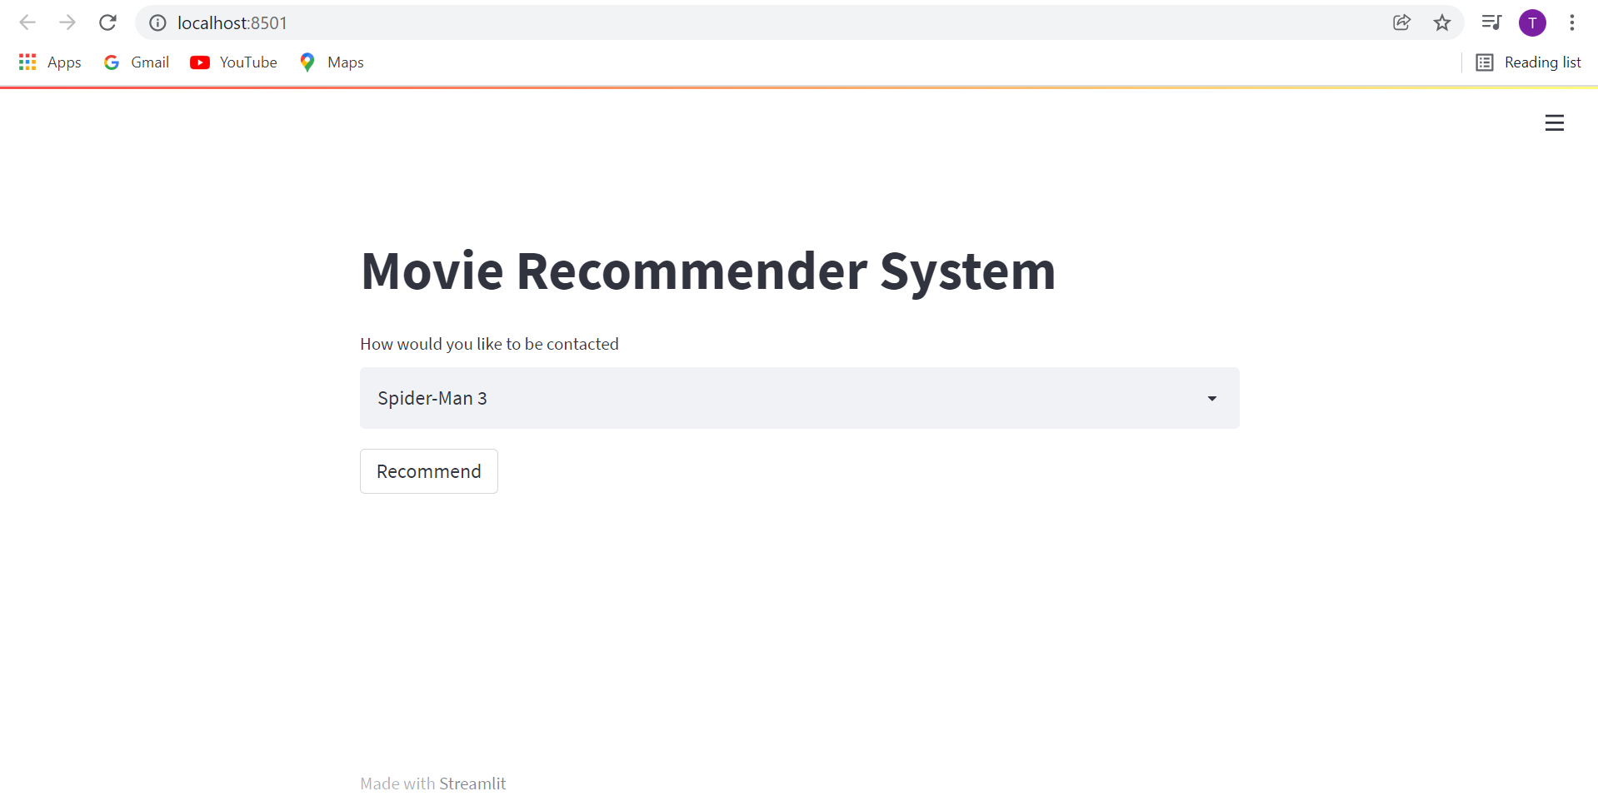
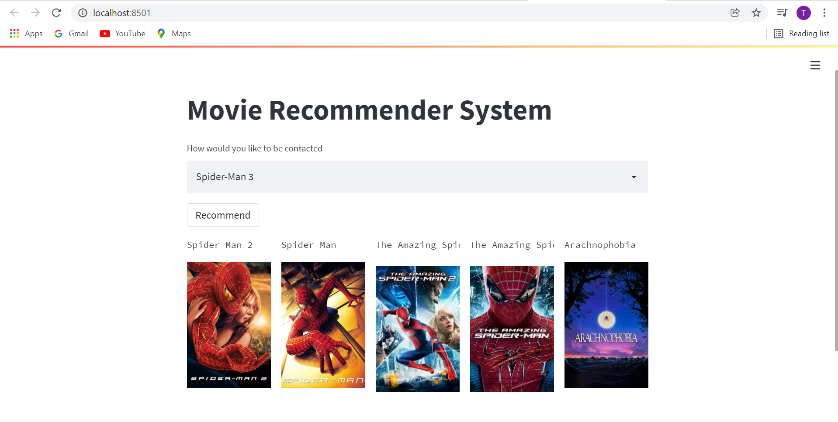
CONCLUSION:
Recommender systems are a powerful new technology for extracting additional value for a business from its user databases. These systems help users find items they want to buy from a business. Recommender systems benefit users by enabling them to find items they like. Conversely, they help the business by generating more sales. Recommender systems are rapidly becoming a crucial tool in E-commerce on the Web. Recommender systems are being stressed by the huge volume of user data in existing corporate databases, and will be stressed even more by the increasing volume of user data available on the Web. New technologies are needed that can dramatically improve the scalability of recommender systems.
REFERENCES
1.Prateek Sappada, YashSadhwani, PranitArora. Movie Recommender System Search Engine Architecture, Spring 2017
2. Movie Recommendation System Using Collaborative filtering, 978-1-5386-65657118/2018 IEEE

